INDIRA GANDHI NATIONAL OPEN UNIVERSITY

REVENUE COLLECTION

PROJECT PROPOSAL

By

//VARSHA

Enroll Num: //119085170

UNDER THE GUIDANCE

OF

Mrs. Anjusha J S



Submitted by the partial fulfillment of the requirement for the award of MCA (Master of Computer Application)
degree of
Indira Gandhi National Open University
2017

SYNOPSIS

TITLE: -

“REVENUE COLLECTION”

DECLARATION

We hereby that the mini project work entitled “REVENUE COLLECTION” submitted to IGNOU Is the original work done by us under the supervision and guidance of Mrs.Anjusha.J.S. This project is submitted in partial fulfillment of the requirements for the award of the BCA.

Signature of the Student and roll No.
///Varsha
Place: Kollam
Date:

BIODATA

ABSTRACT

Revenue Recovery provides software support to the revenue recovery in Mandal and Divisional level. It maintain basic citizen details. Maintain official document transaction details: The documents which are manually moved within the office is tracked and stored in DB. This make the citizens aware of the revenue from the various heads such as library cess, stamp duty, educational cess, etc. The site is developing with front end ASP.NET and backend is SQL SERVER.

ACKNOWLEDGEMENT
The satisfaction that accompanies the successful completion of any task would be incomplete without of the people who made it is possible, whose constant guidance and encouragement crowns all efforts with success. First of all, we thank almighty God, without whose blessings we would not have completed our dissertation successfully. I thank our presents and our family members for their constant encouragement. I are thankful to Dr. T Mahalekshmi, for her wholehearted co-operation and support for providing a wonderful environment. I would like to take this opportunity to express our gratitude towards all the people who have in various ways, helped in the successful completion of the project. I express our gratitude to MRs. Anjusha J S, for giving as a constant source of inspiration and help in preparing the project, personally correcting our work and providing encouragement throughout the project. I also thank our all friends and all those whose helped us directly and indirectly through their valuable suggestions and selfless criticism which come a long way in ensuring that this project become a successful

//Varsha

INTRODUCTION

Citizens can request online services to pay building tax, advertisement tax and professional tax .Create different system users and assign different role with related permissions. Maintaining and Keeping general information of the civilians. Working is made easy for the Mandal Revenue Office in subject to validating and maintaining received documents. Tracking of Civilian information in a state level situation is made easy. Keeping track of the documents, those are submitted by the civilians. Manage all the account details such as user name, department, phone numbers, address, websites, email ID of all the users from one central location.
Advantages of this System:

- This software will reduce manual work and maintain updates in database from time to time.
- It is easy to handle works related to revenue recovery
- Data is secured and easy to retrieve old records in a short time.

EXISTING SYSTEM
The existing system is a manual system. Here the user of the system needs to save his information in the form of excels sheets or Disk Drives. There is no sharing of information is possible if data is in the form of paper or disk drives. Apart from that there are chances of inaccurate data entry and that would lead to chain of problems. Also these systems are fewer user friendly. Files consume lot of space and it is a time consuming process to locate the corresponding files.
DRAWBACKS OF EXISTING SYSTEM
The existing system is a manual system. Here the User of the system needs to save his information in the form of excels sheets or Disk Drives.
  - There is no sharing is possible if the data is in the form of paper or Disk drives.
  - The manual system gives us very less security for saving data; some data may be lost due to mismanagement.
  - It’s a limited system and fewer users friendly.
  - Searching of particular information is very critical it takes lot of time.
  - The users only know his information only not others.
  - It is very critical to share public information to all users
  - Consume more volume of paper work
  - Access of information is difficult.
  - Lack of validation.
PROPOSED SYSTEM
The development of this Revenue Recovery contains the following activities, which try to automate the entire process keeping in the view of database integration approach. User Friendliness is provided in the application with various controls provided by system Rich User Interface. Revenue Recovery makes the overall project management much easier and flexible. It can be accessed over the Intranet. Various classes have been used for file uploading and downloading. The user information files can be stored in centralized database which can be maintained by the system. Revenue Recovery can give the good security for user information because data is not in client machine. Authentication is provided for this application only registered users can access. User can share data to others, and also he can get data from others.

ADVANTAGES OF PROPOSED SYSTEM
- Eliminate the data redundancy in this system.
- Maintenance which was also difficult task in early system.
- A provision to avoid data inconsistency is also provided which makes the new system operation effective.
- The system is user friendly and easily accessible.
- It provides facility for quick information retrieval.
- Decrease response time.

OBJECTIVES

This project ‘REVENUE COLLECTION” is to be developed in ASP.NET and the backend as SQL Server. Applications run faster and encounter large volumes of users without performance problems. SQL Server can support more processes applications, and users in the single system. It allows more security to the data providing user name and password.

- Provides an efficient environment for users.
- Eliminates the drawbacks of Paper documents.
- Avoids the loss of data and time consuming.
- Reduces overall costs.
- Generates Managerial level report.

PROJECT CATEGORY
Website

ANALYSIS

System analysis is the process of gathering and interpreting facts, diagnosing problems and using the fact to improve the system. System analysis deals with a detailed study of various operations performed by the system and their relationship with in an outside the system. System analysis is the heart of the software development. Analysis helps us to understand the present system. System analysis specifies what system should do.

DATAFLOW DIAGRAM

The Data Flow Diagram was first developed by Larry Constantine as a way of expressing system requirements in a graphical form; this led to modular design. A Data Flow Diagram, also known as “bubble chart” has the purpose of clarifying system requirements and identifying major transformations that will become programs in system design. A DFD consists of a series of bubbles joined by lines. The bubbles represent data transformations and the lines represent data flows in the system.
In the DFD, there are four symbols.

- A square ( ( ) defines a source (originator) or designation of system data.
- An arrow ( ) identifies data flow--data in motion. It is a pipeline through which information flows.
- A circle or a “bubble” ( ) represents a process that transforms incoming data flow(s) into outgoing data flow(s).

- An opened rectangle ( ) is a data store—data at rest, or a temporary repository of data.

A few guidelines to aid the derivation of a DFD
- The level 0 DFD should depict the software/ system as a single bubble
- Primary input and output should be noted
- Refinement should begin by isolating candidate processes, data objects and the stores to be represented in the next level.
- All arrows and bubbles should be labeled with a meaningful name
- Information flow continuity must be maintained from level to level and one bubble at a time should be refined.

Level 0 DFD (Context Diagram)
Admin

Revenue Recovery
0
Request
Response
Employee
User
Response

Request
Request

Response

Level 1 DFD
Tbl_division
Tbl_empreg
login
Register

Registration 0.1
Username

Change Password
0.2
E-mail id
Password

Username

Approve Employees & send mails 0.4

empcode

Add news, district, area
0.3
did
did
empcode
news
nid
mid
Tbl_model
Tax Request
0.5
buildtaxreq
bid
adtaxreq
aid
aid
Feedback
0.6
feedbackid
Tbl_feedback

Registration details

Level 2 DFD

Building Tax
0.5.1

applicationno
Advertisement tax
0.5.4
Approve Request
0.5.2
professionaltax
Professional Tax
0.5.3

pid
professiontype
typid
type
proftaxsettings
applicationno
Tbl-Model
buildingsettings
buildinginfo
adtaxtype
adtaxsettings
buidtaxreq
adtaxreq
Building Tax payment
0.5.2
professionalincome
Professional Tax payment
0.5.2
Receipt
Advertisement Tax payment
0.5.2
status
receiptno
status
receiptno
status
status

status
status
receiptno
status
buildingdetails
advertisement details
de

de
aid
type
mid
mid
rqid
bid
aid
aaid
adap
Ptc-no
status
pincomeid
status
buildid
bid
status

type
Receipt

Receipt Receipt

E-R DIAGRAM

Entity – Relationship Diagram: This depicts relationship between data objects. The attribute of each data objects noted in the entity- relationship diagram can be described using a data object description. Data flow diagram serves two purposes:
1. To provide an indication of how data are transformed as they move through the system.
2. To depict the functions that transformation the data flow.
Data Objects: A data object is a representation of almost any composite information that must be understood by the software. By composite information, we mean something that has a number of different properties or attributes. A data object encapsulates data only there is no reference within a data object to operations that act on the data.

Attributes: Attributes define the properties of a data object and take on one of three different characteristics. They can be used to: Name an instance of data object. Describe the instance. Make reference to another instance in other table.
Relationships: Data objects are connected to one another in a variety of different ways. We can define a set of object relationship pairs that define the relevant relationships

ER Diagram

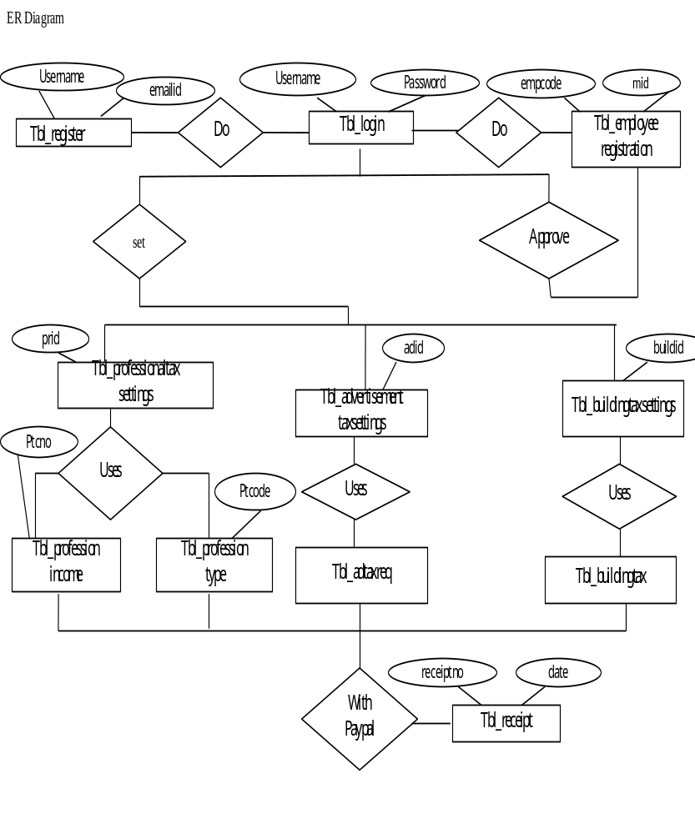

TABLES

- Table Name : Tbl_adtaxtype
Description : Contain details of advertisement tax request
FIELD NAME | DATATYPE | CONSTRAINTS | DESCRIPTION
Adap | Int | Primary Key | Advertisment tax RequestIId
Aid | Int | Foreign Key | Advertisment tax Type
Area | varchar(50) | Not Null | Area
Width | numeric(18, 0) | Not Null | Width
Height | numeric(18, 0) | Not Null | Height
Date | Date | Not Null | Date
Address | varchar(50) | Not Null | Address
Mid | Int | Foreign Key | Area Code
Distancefronroad | numeric(18, 0) | Not Null | Distancefronroad
Level | varchar(50) | Not Null | Level
Uid | varchar(50) | Not Null | Uid
Status | varchar(50) | Not Null | Status
Tota | numeric(18, 0) | Not Null | Total Amount
Details | varchar(50) | Not Null | Details

- Table Name : Tbl_adtaxsettings
Description : Contain details of advertisement tax type
FIELD NAME | DATATYPE | CONSTRAINTS | DESCRIPTION
Aaid | Int | Primary Key | Advertisment tax Settings id
Aid | Int | Foreign Key | Type
Area | varchar(50) | Not Null | Area
Widthfrom | numeric(18, 0) | Not Null | Width from
Widthto | numeric(18, 0) | Not Null | Width to
Hfrom | numeric(18, 0) | Not Null | Height from
Hto | nchar(10) | Not Null | Height to
Rate | numeric(18, 0) | Not Null | Rate

- Table Name : Tbl_buildinginfo
Description: Table contain building information
FIELD NAME | DATATYPE | CONSTRAINTS | DESCRIPTION
Buildid | Bigint | Primary Key | Building id
Mid | Int | Foreign Key | Area Code
Area | varchar(50) | Not Null | Area
Village | varchar(50) | Not Null | Village
Ward | varchar(50) | Not Null | Ward
Dorno | varchar(50) | Not Null | Door no
Ownername | varchar(50) | Not Null | Owner name
Description | varchar(50) | Not Null | description
Functionality | varchar(50) | Not Null | functionality
Totarea | numeric(18, 0) | Not Null | Total area
Yearofbuild | numeric(18, 0) | Not Null | Year of build
Typeofconstruction | varchar(50) | Not Null | Type of construction

- Table Name : Tbl_buildingtaxsettings
Description : Contain information about building tax
FIELD NAME | DATATYPE | CONSTRAINTS | DESCRIPTION
Bid | Int | Primary Key | Building Setting Id
Purpose | varchar(50) | Not Null | Purpose
Areatype | varchar(50) | Not Null | Area type
Areafrom | varchar(50) | Not Null | Area from
AreaTo | varchar(50) | Not Null | Area To
Agefrom | Int | Not Null | Age from
Ageto | Int | Not Null | Age to
Contructiontype | varchar(50) | Not Null | Contruction type
Rate | numeric(18, 0) | Not Null | Rate
Librarysess | numeric(18, 0) | Not Null | Library sess
Servicesess | numeric(18, 0) | Not Null | Service sess
Surcharge | numeric(18, 0) | Not Null | surcharge

- Table Name : Tbl_adtaxtype
Description : Contain details of advertisement type
FIELD NAME | DATATYPE | CONSTRAINTS | DESCRIPTION
Aid | Int | Primary Key | Type Id
Type | varchar(50) | Not Null | Type Name

- Table Name : Tbl_buildingtaxreq
Description : Contain details of building tax request
FIELD NAME | DATATYPE | CONSTRAINTS | DESCRIPTION
Rqid | Int | Primary Key | Request Id
Assessmentyear | varchar(50) | Not Null | Assessment year
Lid | Int | Foreign Key | Building Id
Amount | numeric(18, 2) | Not Null | Amount
Date | Date | Not Null | Date
Uname | varchar(50) | Foreign Key | User Name
Ramark | varchar(MAX) | Not Null | Ramark
Mid | Int | Foreign Key | Area Code
Status | varchar(50) | Not Null | Status
Lybrarysess | numeric(18, 0) | Not Null | Library sess
Serviceses | numeric(18, 0) | Not Null | Service ses
Surcharge | numeric(18, 0) | Not Null | Surcharge
Tot | numeric(18, 0) | Not Null | Total

- Table Name : Tbl_login
Description : Contain login details
FIELD NAME | DATATYPE | CONSTRAINTS | DESCRIPTION
Username | varchar(50) | Primary Key | Username of users
Password | varchar(50) | Not Null | Password of users
Role | varchar(50) | Not Null | Role of users

- Table Name : news
Description : Contain details of news
FIELD NAME | DATATYPE | CONSTRAINTS | DESCRIPTION
Nid | Int | Primary Key | News id
News | varchar(MAX) | Not Null | News
Date | Date | Not Null | Date

- Table Name : Tbl_professiontype
Description : Contain details of professional type
FIELD NAME | DATATYPE | CONSTRAINTS | DESCRIPTION
Typid | Int | Primary Key | Type id
Cat | varchar(50) | Not Null | category
Type | varchar(50) | Not Null | Type name

- Table Name : Tbl_professionalincome
Description : Contain income details
FIELD NAME | DATATYPE | CONSTRAINTS | DESCRIPTION
Pincomeid | Int | Primary Key | Professional incomeid
Ptc | varchar(50) | Foreign Key | Professional Tax Code
Assesmentyear | varchar(50) | Not Null | Assessment year
Income | numeric(18, 0) | Not Null | income
Tax | numeric(18, 0) | Not Null | Tax
Paydate | Date | Not Null | Pay date

- Table Name : Tbl_professionaltax
Description : Contain professional tax details
FIELD NAME | DATATYPE | CONSTRAINTS | DESCRIPTION
ApplicationNo | varchar(50) | Primary Key | Professional Tax Code
Type | Int | Foreign Key | Type
Name | varchar(50) | Not Null | Name
Place | varchar(50) | Not Null | Place
Address | varchar(50) | Not Null | Address
Apfn | varchar(50) | Not Null | Licence File Name
Licenceno | varchar(50) | Not Null | Licence no
Otherinfo | varchar(50) | Not Null | Other info
Staff | varchar(50) | Not Null | Staff

- Table Name : Tbl_profftaxsettings
Description : Contain professional tax settings details
FIELD NAME | DATATYPE | CONSTRAINTS | DESCRIPTION
Pid | Int | Primary Key | Professional tax Code
Type | Int | Not Null | Type
Amtfrom | numeric(18, 0) | Not Null | Amt from
Amtto | numeric(18, 0) | Not Null | Am tto
Tax | numeric(18, 0) | Not Null | Tax

- Table Name : Tbl_register
Description : Contail registration details of user
FIELD NAME | DATATYPE | CONSTRAINTS | DESCRIPTION
Firstname | varchar(50) | Not Null | First name
Lastname | varchar(50) | Not Null | Last name
Contactno | varchar(10) | Not Null | Contactno
Username | varchar(50) | Primary Key | User name
Regisdate | Date | Not Null | Registration date

- Table Name : Tbl_receipt
Description : Contain receipt details
FIELD NAME | DATATYPE | CONSTRAINTS | DESCRIPTION
reciptNo | Int | Primary Key | Recipt No
Rdate | Date | Not Null | Recipt date
Taxtype | varchar(50) | Not Null | TAX TYPE
Amount | varchar(50) | Not Null | AMOUNT
Paidby | varchar(50) | Foreign Key | PAIDBY
Id | Int | Foreign Key | Tax request Id

- Table Name : Tbl_district
Description : Contain details of district
FIELD NAME | DATATYPE | CONSTRAINTS | DESCRIPTION
Did | Int | Primary Key | Did
Dname | varchar(50) | Not Null | District name
Description | varchar(50) | Not Null | Description

- Table Name : Tbl_empregistration
Description : Contain details of employee
FIELD NAME | DATATYPE | CONSTRAINTS | DESCRIPTION
Empcode | Int | Primary Key | Employee code
Mid | Int | Foreign Key | Area Code
Empname | varchar(50) | Not Null | Employee name
Address | varchar(50) | Not Null | Address
Contactno | varchar(10) | Not Null | Contactno
Emailed | varchar(50) | Not Null | Emailed
Idproof | varchar(50) | Not Null | Idproof

- Table Name : Tbl-area
Description : Contain details of area
FIELD NAME | DATATYPE | CONSTRAINTS | DESCRIPTION
Mid | Int | Primary Key | Area Code
Did | Int | Foreign Key | District Code
Mname | varchar(50) | Not Null | Area

- Table Name : Tbl_feedback
Description : Contain feedback details
FIELD NAME | DATATYPE | CONSTRAINTS | DESCRIPTION
Feedbackid | int | Primary Key | Feedback id
Feedback | Varchar(MAX) | Not Null | Feedback details
Date | date | Not Null | Date of feedback

PROCESS LOGIC OF EACH MODULE

ADMINISTRATOR
The administrator login to the system using his or her username and password, if the username and password are valid then the user is authenticated otherwise the user is denied from entering the system. After the successful login the main function associated with admin are:-
- Add District
- Add Area
- Approve Employee
- Add News
- View Payment
- Tax Settings
- Change Password

EMPLOYEE

In this module the employee login into the system using his/her username and password, if the username and password are valid then the user is authenticated otherwise the user is denied from entering the system. After the successful login the main function associated with employee are:-
- Add Building Tax Information
- Add Professional Type
- Add Professional Income
- Approve Tax Request
- Change Password

USERS
In this module the user also login into the system using his/her password, if the username and password are valid then the user is authenticated otherwise the user is denied from entering the system. If the Person is a new user, then he/she gets the facility to create an account. After the successful login the main function associated with the user are:-
- Request For Payment
- Pay Taxes Using Paypal Service
- Change Password

INPUT DESIGN
Input design is the process of converting a user – oriented description of the inputs to a computer based business system into a programmer – oriented specification. The goal of designing input data is to make data entry as easy, logical and free from errors as possible. Input design is a part of the overall system design, which requires carefully attention. If the data going into the system is incorrect, then the processing and output will magnify these errors. The proposed system satisfies the following input design objectives
- A cost effective method of input
- The highest possible level of accuracy
- The input is acceptable to and understood by the user staff.
Input Objectives are
(i) Controlling the amount of input: Wherever user input is required, the number of key strokes is reduced by giving possible input values as default in that area. The viewer can select the answer in single click. The amount of information entered by the viewer using the keyboard is reduced to the maximum and the software is made very user friendly.
(ii) Avoiding Delay: A processing delay resulting from data preparation or data entry operations is called a bottleneck. Such bottlenecks are avoided to the maximum. The only time the viewer has to wait is when the file is uploaded or downloaded. Progress bar or progress meters are displayed to keep the user waiting and also to show the speed and amount of download.
(iii) Avoiding Errors in Data: The rate at which errors occur depends on the quantity of data. Here the quantity of data is reduced to the lowest, and a text file is easily manageable.
(iv) Avoiding Extra Steps: The viewer can quit at any point of time. Even at the time of upload or download the viewer can quit. The viewer need not wait for any specific event to happen for quitting the process.
(v) Keeping the process Simple: This implies that the system has all the measure to keep the errors out even if the user is giving wrong data. It handles the situation with grace and doesn’t create much hype about the situation to the user. Several activities done in the input stages are:

- Data recording → collection of data at its source
- Data transcription → transcription of data to an input form
- Data conversion → conversion of the input data to a computer acceptable medium
- Data verification → checking the conversion
- Data control → checking the accuracy and controlling the flow of the data to the computer
- Data transmission → transmitting or transporting, the data to the computer.
- Data validation & correction → checking & correcting the errors the input data by program when it enters the computer system.

HARDWARE REQUIREMENT

Processors : Intel Pentium core processor
Processor speed : 3GHz
RAM : 1GB
HDD : 1GB free space
Monitor : 17”
Keyboard : Standard
Mouse : Standard
Printer : Standard.

SOFTWARE REQUIREMENTS FOR DEVELOPMENT
Operating system : Windows 7
Programming Tool : MS Visual Studio .Net2008
Front End : ASP.Net3.5
Middle Tier : C#. Net
Back End : MS SQL Server 2008

FUTURE ENHANCEMENT

The future enhancement of our project is to reduce the limitation to some extent. The enhancement may be required if there is any change in the requirements, user environment or priorities. Enhancement means adding, modifying or developing the code to support the changes in specification. Every module in the system is being developed carefully such that the future enhancement do not affect the basic performance of the system. In future we can add any links or services to the system very easily.

